DAWN HOUSE SCHOOL – STAFF HANDBOOK
Policy Title: Behaviour Policy (Education Committee for ratification)
Section: B | Policy No: B.1
Version Date:  June 25 | Review Date:  September 26
Name of Originator: JB | Designation: Assistant Head Teacher

We aim to provide an environment that:
- Enables learning for all within our community.
- Fosters respect and empathy for others and acceptance of differences.
- Built upon cooperation and collaborative working to give everyone a feeling of belonging.
- Supports pupils in developing the strategies to self-regulate and manage their own behaviour and take responsibility for their actions.
- Ensures everyone feels safe, cared for and valued.
- Creates and maintains a safeguarding culture in school where staff are open to sharing any concern regarding a pupil or member of staff no matter how small.
Child on Child Abuse:
All staff should be aware that children can abuse other children (often referred to as child-on-child abuse). This is most likely to include, but may not be limited to:
- bullying (including cyberbullying).
- physical abuse such as hitting, kicking, shaking, biting, hair pulling, or otherwise causing physical harm.
- sexual violence, such as rape, assault by penetration and sexual assault.
- sexual harassment, such as sexual comments, remarks, jokes, and online sexual harassment, which may be stand-alone or part of a broader pattern of abuse.
- upskirting, which typically involves taking a picture under a person’s clothing without them knowing, with the intention of viewing their genitals or buttocks to obtain sexual gratification, or cause the victim humiliation, distress, or alarm.
- sexting (also known as youth produced sexual imagery); and
- initiation/hazing type violence and rituals.
Low Level Safeguarding, and Bullying Concerns
Dawn House School develops a culture of openness and support staff through induction training and at other times are encouraged to aware of their own actions and those of others. Staff are encouraged to report anything that may cause them to be uncomfortable or have a “nagging” doubt around the action or behaviour of an adult which would not meet the “harms threshold” Low level concerns may be over familiarity with pupils, having favourite, or anything else which would raise a doubt.
All low-level concerns are reported to the Principal or Deputy Principal using a low-level concern form. The Principal or Deputy will advise the staff member reporting when an issue has been dealt with as feedback. All low-level concerns and subsequent notes and actions are store securely within the principal’s office.
To achieve this environment, we will:
- All be responsible for creating a calm, purposeful and positive environment.
- Provide a curriculum that is engaging, relevant, challenging and aspiring.
- Continually work together to ensure that we all have an understanding and acceptance of differences.
- Work in partnership with pupils, parents, and other agencies in the best interests of all pupils.
- Share the principles of this policy, and our expectations of pupils, parents, and adults in school through our home school agreement
- Have a shared understanding of policies and procedures and apply them well.
- Understand and accept our individual responsibility and accountability in helping pupils learn.
- Ensure that the teaching and modelling of personal, social, and emotional development is central to our whole provision
- Model that development through our own conduct and through whole school approaches including restorative practice and zones of regulation
- Continually develop and train staff so that they have the necessary fundamental knowledge to help pupils learn and behave well, including training on this policy during their induction programme
- Make the standards we expect explicit to all.
- Ensure that any strategy for helping pupils learn to behave is agreed a result of a core team or focus meeting and in consultation with Health and wellbeing team and SLG if appropriate.
- Effectively communicate with pupils and parents/carers the high expectations for learning and behaviour.
We recognise that:
- There are always reasons behind why a pupil is unable to learn effectively and displays behaviour that hinders learning and that those behaviours communicate a need.
- these behaviours that hinder the individual impact on the learning of others.
- the needs of all pupils are different and that a personalised approach is necessary.
- pupils and parents/carers have an invaluable role to play to maintaining standards.
- other agencies can support and inform our practice.

Positive Learning behaviours- The Dawn House Way
Pupils will | Adults will
Be safe. Be kind. Be in the right place  Tell an adult if you have a problem  Join in with lessons, do your best work and ask for help  Respect other people's opinions and beliefs and differences  Look after our school, walk calmly  Speak up if you think someone is not safe  Speak up if something is not fair  When things go wrong, talk about what  happened, how put it right and what to do next time | Show us what kindness, good behaviour and trying your best look like -even if you are in a bad mood!  Respect other people's opinions and beliefs and differences  Tell us when we do well- give merits fairly every lesson  Understand behaviour is part of how we communicate- help us to learn to Speak up about our needs and wants politely  Help us understand how we behave has affects that can be good or bad, and how to use strategies to help  Speak up when someone is not safe or things are not fair.  When things go wrong, help us think and talk about what happened, who was affected, how to put it right and what to do next time

Core Team Meetings
May be called by a pupils’ core team to discuss issues of concern at any time. Any action plan developed as a result must be shared with and approved by the appropriate Lead Practitioner or member of SLG before actions are implemented. It is the responsibility of the form tutor to ensure that the meeting is minuted and the minutes are distributed to all involved. When appropriate parents/carers should be informed/involved. After approval by the principal (where necessary) pupils should be informed of outcomes and/or actions.

Focus Meetings
May be called by any child facing member of staff. Focus Meetings may be called at any time to discuss issues of concern about a pupil or group of pupils. Focus meetings can involve a number of different staff involved in teaching/caring for a pupil. A member of the Health and Well Being team should always attend. Focus meetings are a useful forum for airing and sharing concerns/formulating specific action plans and for ensuring that members of SLG are made aware of these concerns. Minutes should be taken and then strategies for implementation shared in briefings and by email /teams as appropriate. Core teams should then monitor the impact of these strategies and call further meetings if ineffective.

Views and actions shared at focus meetings should not be shared outside of the school until they have been agreed by a Senior Leader . As such minutes should not be shared with pupils, parents/carers, LA’s unless there is an agreement with SLG.
Appendix 1

Positive Behaviour support Plans (PBSP’s)

The needs of some pupils are such that they need support beyond that given as a matter of to all pupils. This can include behaviours that are distressing to the child themselves but have little impact on others. They are guides to help adults help the child.

The PBSP should be drawn up by the core team, Lead Practitioner, RCW, and any other professional working with the child in school with support from the Behaviour for Learning Team. A member of SLG must agree the content of the plan before it is implemented.
The core team meeting should:
- Identify all the aspects of behaviours exhibited in school.
- Decide on the behaviours the student needs to learn and be supported to develop in school and in the residential setting.
- Identify triggers and decide on the strategies to be used to support the pupil in learning how to self- regulate and behave. Strategies may draw on a pupil’s sensory diet and should reflect their individual and communication needs.
- Agree who is to be involved in implementing the plan.
- Agree the rewards and responses or sanctions to be used to support the change.
- Identify any possible physical intervention (including escort holds) that may be used and note them in detail in the plan.
- Identify any additional support required, e.g. from SLG, time out activities, personalisation of learning programme etc or involvement of outside agencies and discuss these with relevant person.
- Agree on the timescale for implementing the plan and set a review date.
- Seek the agreement of a Senior Leader
- Share with the wider staff any new information or changes
- Lead Practitioners will share the plan with parents/carers
- Ensure all staff involved in implementing the plan are informed by the Core Team via email.

PBSPs are stored on the Solar System so that they can easily referred to when an incident form is completed. This is important so current strategies are reviewed for success, reconsidered if unsuccessful and successful new approaches are recorded and shared.

Appendix 2

REWARDS AND SANCTIONS
Pupils at KS 2, 3 and 4 are able to collect merits if they are able to…
- Develop- let adults help, knowing that it is ok to make mistakes so we can learn from them
- Engage- being curious, joining in
- Communicate- kind words, working with peers, asking for help
- Aspire- being ambitious and trying your best with work and friendships, working towards your goals
These should be awarded one at a time in direct explicit response to good behaviours for learning. Pupils can use their merits to access enrichment time on a Friday. All pupils are able to access a range of activities identified by the pupils themselves with a higher number of merits needed to achieve the most prized activities. The merit system has been designed to appeal to pupils for whom extrinsic motivation is successful whilst giving pupils the opportunity to recognise and develop the feelings associated with intrinsic reward. It is important that rewards are experienced as positive shared experiences with their peers as part of the school community.
In addition…
Achievement Assemblies once per half term will promote and recognise the positive steps forward students make through:
Tutor recognition awards.
Improvement awards.
Principals Award.

INDIVIDUAL REWARDS
Staff will need to consider how the student is to be motivated to achieve the target behaviours. Rewards here are likely to be more frequent. It is very important to choose a reward that will be effective and relevant to the level of achievement. Rewards may be tangible (see list below) or may simply be praise, attention display of work, informing other staff of good work, postcards, or a call home etc. Students indicated through the Pupil Leadership Group that they valued having for e.g. extra time with friends or tea and biscuits.
NB “Approval” is the most powerful reward.

PERMITTED SANCTIONS

All sanctions or responses should be relevant to the unwanted behaviour and should be imposed as soon as possible following an incident and appropriate to the individual student needs and understanding.
Sanctions are more easily applied if you discuss the incident with the pupil and agree on an appropriate response. Where possible, a restorative conversation or circle should be used to provide a framework to gather the pupils’ views, establish facts, support the pupils’ and their peers understanding of an incident, to repair and relationships and identify ways to support the child and improve their behaviour. Ideally a pupil should agree that:
- It was wrong to behave in the way they did.
- It is reasonable in the circumstances for a sanction to be imposed.
- It is right for them to do the sanction.

You should be aware that you are responsible for managing the sanction, supervising the pupil, and informing the child’s parents that sanction has been given.
You should not impose a sanction for someone else to carry out on your behalf, unless by prior agreement.
This is particularly important when an incident happens during the school day.
Sanctions cannot be imposed for care staff to manage, unless this has been agreed with Principal or and Residential Services Manager.
The following are examples of permitted sanctions:
- Verbal reprimand (with an explanation and appropriate support for their communication needs)

Loss of privilege.
- Miss an activity.
- Having a different breaktime if a pupil has been unsafe, bullied or harmed others at a previous break time
- In residential setting, staff to choose an appropriate activity for the pupil.
- Spend specified short time away from peer group with appropriate work and supervision- this constitutes removal and should be recorded on the incident form
- Contribute towards the cost of loss/damage to property or belongings.
- Pupil to complete/re-do unfinished or spoiled work.
- Withhold a reward which others in the group are to receive.
- Pupil to make reparation for their behaviour, e.g. repairing or tidying after causing damage, a kind deed etc.
- Suspension or External exclusion Note: This can only be authorised by the Principal In response to serious breaches or persistent breaches of the school's behaviour policy; and if allowing the pupil to remain in school would seriously harm the education or welfare of the student or others in the school. (See exclusions statement)
SANCTIONS THAT INFRINGE PUPILS’ RIGHTS WILL NOT BE USED e.g. withholding food/refreshment or entitlement from the curriculum.
Important Definitions:
Removal: not be confused to separation or workrooms used for non-disciplinary reasons, only be used as a last resort to restore order and calm following an unreasonably high level of disruption, disruptive pupils to be taken to a place where education can be continued in a managed environment. The Principal ) should have oversight of removal. Schools should have regard to their duties towards pupils with SEND in cases of removal.
Seclusion:
- Forced to spend time alone against will (requires statutory powers other than in an emergency).

Time out:
- Restricting positive reinforcement as part of a planned behavioural programme i.e. A PBSP (requires written agreed plan).

Withdrawal:
- Removed from the situation but observed and supported until they are ready to resume.
IF YOU ARE IN ANY DOUBT, PLEASE DISCUSS WITH YOUR LINE MANAGER BEFORE MAKING A DECISION ABOUT A PARTICULAR SANCTION.
See also
- The Equality Act 2010
- KSCIE 2025
- Prevent strategy 2019
- Children and Families Act 2014
- Behaviour in schools: Advice for headteachers and school staff February 2024
- Safeguarding Policy
- Exclusion Statement
- Physical Contact Policy
- Anti-bullying and harassment policy
- Staff conduct policy
- Whistle blowing policy
- Staff dress code.
- Section550ZA of the Education Act 1996
- Children Missing from Care policy

Appendix 3
RECORDING and REPORTING INCIDENTS and the use of PHYSICAL INTERVENTIONS and SANCTIONS
All significant or serious incidents, physical interventions and sanctions are to be using the Solar Behaviour Incident form within 24 hours. Refer to Contact Policy
In cases where a child has been injured the adult involved should complete the medical tracking system (currently My Medical Tracker); in cases where an adult has been injured, they should complete the accident book after seeking medical attention from the nurse or first aider.
In cases where there has been a physical intervention or use of force, the adult involved should ensure that the relevant details are involved in the reports and that the pupil is checked by the nurse or a first aider afterwards (not someone directly involved in the incident).
Where a physical intervention has taken place, or a child is significantly distressed parents should be informed as soon as possible the same day.
All action determined and carried out as a result of an incident or safeguarding concern should be recorded in appropriate documents, e.g., telephone contact with parents recorded in professional notes/ files, letters home in pupil’s file, WEDUC communications, changes to PBSP and /or risk assessment , work undertaken with pupils recorded in SLT/ teacher’s records etc.
After the incidents form is completed the Lead Practitioner for the pupil’s key stage or area of school should review the incident and follow up on any actions or staff or pupil debrief. All Senior Leaders in the Education Team and the Principal receive an alert.
Monitoring
The Assistant Principal leading Behaviour for Learning and the Behaviour for Learning Team will monitor and record levels and nature of incidents on a fortnightly basis. Data showing emerging patterns and trends are then used to inform strategic planning and identify appropriate interventions for groups and individuals
Formal analysis of behaviour is updated on a termly basis and evaluation include numbers of incidents per child, key stage, school department, and place.
Incident reporting is monitored on behalf of Speech and Language UK by the Care Standards Visitor each half term.

Appendix 4-Home School Agreement

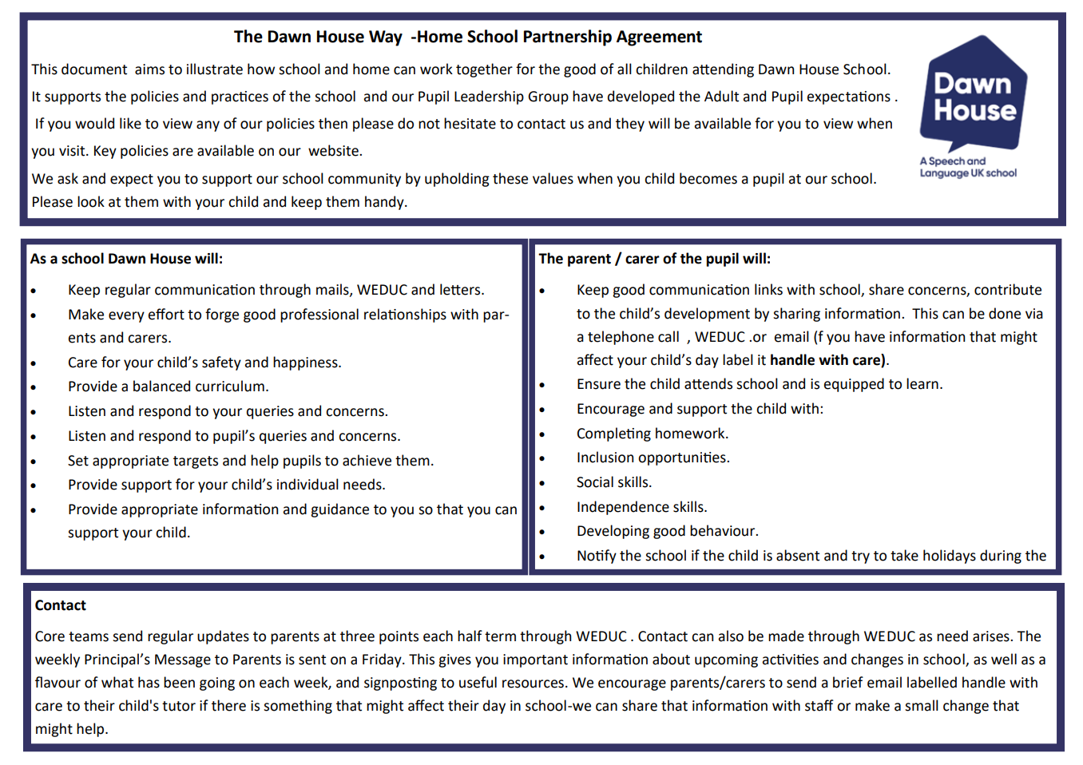

Appendix 5-The Dawn House Way ( good behaviours for learning) Visual Resource
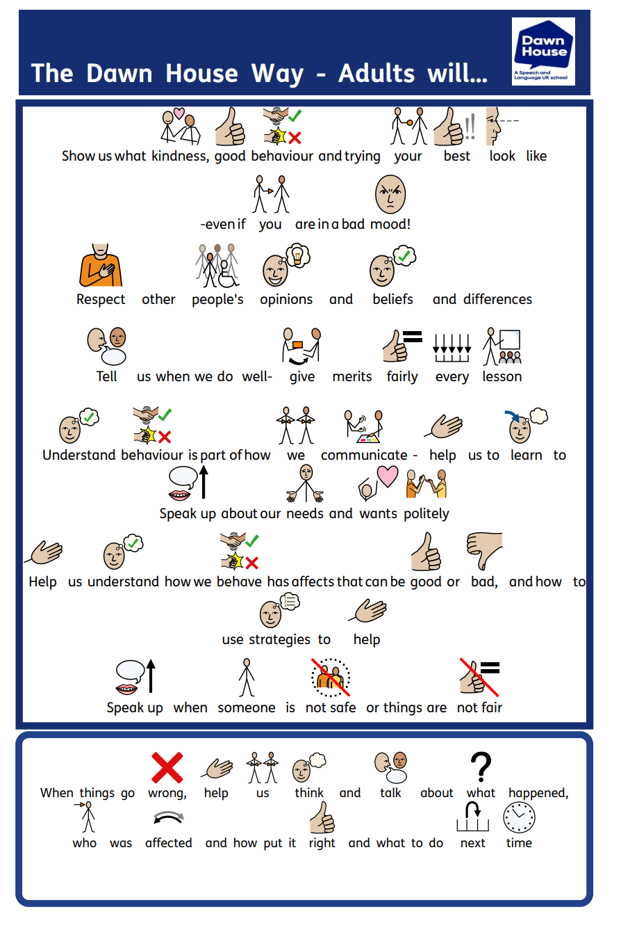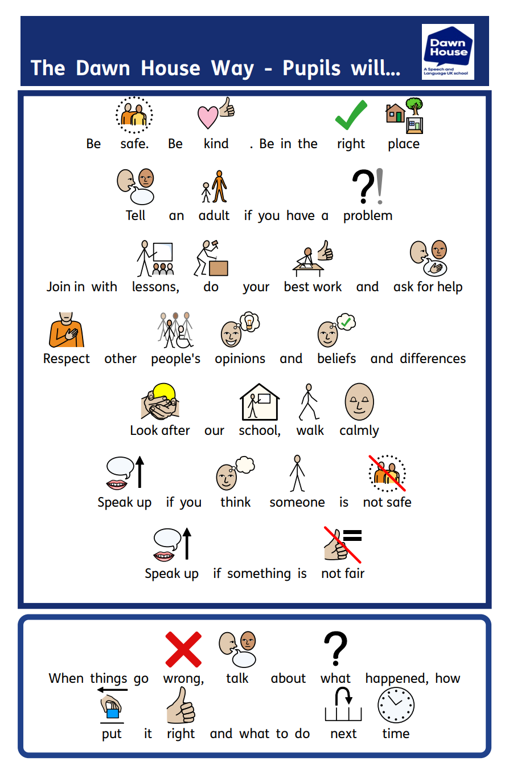
Appendix Six – Roles and Responsibilities