

DAWN HOUSE SCHOOL – STAFF HANDBOOK
Policy Title: Fire Safety Management Policy

Version Date: July 2025 | Review Date: July 2026
Name of Originator: SBM & Premises Manager | Designation: SBM

This document forms part of Dawn House’s written safety policy arrangements. Departments, services or teams may consider it appropriate to develop additional guidance and systems of work on specific work related activities.
Where proposals, additional guidance or changes to systems of work will have an impact on health, safety and welfare, there must first be consultation affected colleagues and The Dawn House Health Safety Committee.
If you have any questions or require further information or support on the contents of this document, please contact The Premises Department.

Manager Responsibilities
Below is an overview of the responsibilities which is intended to support managers in identifying their key duties that need to be taken to comply with the requirements of this document and the safety management systems of Dawn House School.
- Managers must ensure that fire precautions are in place to maintain the safety of colleagues and pupils including service users, visitors and contractors in the event of a fire occurring;
- Managers must ensure that the Management of Fire Risk Assessment is in place and completed by a competent person for any locations that they manage and where their colleagues are based;
- Managers must ensure suitable and adequate fire fighting equipment is in place to assist persons to enable evacuation to a place of safety in the event of an emergency;
- Premises managers need to have considered the routes to emergency exits and those fire exits are kept clear, not secured or locked and lead to a place of safety (certain premises may be required to secure exits to protect children or other vulnerable persons but this must be backed up by identified procedure and clearly identified within the Management of Fire Risk Assessment);
- Managers need to ensure that any evacuation that does not take people outside but to another location within the premises (horizontal / lateral evacuation), a minimum 30-minute fire door and compartmentalisation zones must be clearly identified and all colleagues must be trained and made aware of the location of these fire zones within the premises;
- Managers must ensure that all colleagues are given training on their induction which must include the specific fire procedures of the premises, methods of evacuation, locations of fire exits, raising the alarm, the location of the evacuation point and any other relevant fire information which could affect them in the event of an emergency;
- Managers need to ensure that all colleagues have received appropriate suitable training on a regular basis to ensure that they are aware of the fire prevention measures within the premises and their roles and duties during an emergency. The complexity of this training needs to be identified within the fire risk assessment and may include a mix of formal training sessions, discussion of fire safety within team meetings or other fire information, supplemented by fire drills;
- Managers should consider the need for fire wardens within your premises as part of the Management of Fire Risk Assessment;
- Managers may need to provide information to colleagues on the use of Fire Fighting Equipment (FFE). This information should clarify that FFE should only be used to aid evacuation.
- Managers are required to provide to any employer of a person whom may visit from an outside organisation with information on risk in relation to fire safety and also provide these persons with all necessary fire instructions (contractor management).

Employee Responsibilities
The Health & Safety at Work Act 1974 section 7 requires all employees to consider their own health & safety and the safety of others. As an employee of Dawn House School, if you have concerns in relation to health & safety that is likely to cause you or someone else, injury or ill health then you must ensure that the concern is communicated to your manager immediately. You are also required to co-operate with the management of Dawn House School to ensure compliance with the health & safety arrangements, policies and procedures and work to the requirements identified within this document.

What Causes Fire

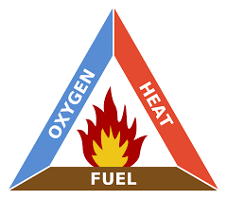

In order for the combustion process to take place, 3 elements are required which are fuel, heat and oxygen and this often referred to as the fire triangle.
With these 3 elements in place, all that is then required is an ignition source and you have a fire. There are numerous sources of ignition excluding arson in non-domestic fires and the most common causes are identified below. Managers should understand that in a school environment, most of fire incidents that occur are caused by arson or other malicious / deliberate actions. Vigilance and monitoring by all colleagues can reduce the potential for this type of fire incident to occur supported by simple measures such as good housekeeping and reducing or removing combustible materials are storing items correctly will reduce the potential for malicious fires to take occur.

Regulatory Reform (Fire Safety) Order 2005
This legislation requires all employers to manage their own fire safety arrangements and includes a statutory requirement for the completion of a fire assessment for each premises under their control. This legislation also requires employers to identify any responsible persons who will manage fire safety and undertake a risk assessment. When considering fire management and the risk assessment, the following areas should be considered:
- fire safety arrangements for the premises;
- elimination and reduction of fire risks;
- fire-fighting equipment and methods of detection;
- emergency routes and exits;
- information and training to employees;
- co-operation and co-ordination of shared workplaces.

Responsible Persons – Legal Definition

The Regulatory Reform (Fire Safety) Order 2005 identifies that the responsible person is defined as the employer / manager, if the workplace is to any extent under their control For Dawn House School, this definition identifies that Managers / Head Teachers / Premises Managers can all be considered to be responsible persons under the definition of the legislation. Fire Risk Assessment Managers need to ensure that each of the premises which are occupied by Dawn House School colleagues has a completed fire risk assessment. Under the Regulatory Reform (Fire Safety) Order 2005 a fire risk assessment shall be completed in all workplaces by a competent person. To be deemed a competent person, you must be able to demonstrate training in the fire risk assessment principals and have experience of and knowledge of fire risks that will impact on the safety of colleagues. The assessment must include:
- The means of detecting a fire and giving warning in the event of a fire;
- Provision of suitable fire-fighting / safety equipment;
- Maintenance of fire-fighting / safety equipment;
- The means of escape from the building;
- Provision of fire safety training and evacuation drills;
- Analysis of ignition sources; • Analysis of combustible materials.

Enforcement and Regulating Fire Precautions

Nottinghamshire Fire and Rescue Service is the enforcement body for ensuring compliance with all fire related legislation. Local fire authorities no longer offer general advice on fire safety for premises. If you require advice or assistance on fire safety matters contact The Premises Department.
Fire Brigade Attendance to any Incident The Fire Service will not automatically attend your site during normal building operating times until there has been confirmation that their attendance is required. Dawn House main school fire alarm is monitored by EMCS. In the event of a fire activation at the main school Juniors or Residence, EMCS will firstly ring the school to confirm the fire then alert the Fire service then call nominated persons. When the building is occupied and the fire alarm is activated, if a fire is suspected or there are signs of fire, a 999 call must be made.

Extinguishing Fires
When considering fire evacuation and fire fighting arrangements, it must always be remembered that people are always more important than property. Training in the use of extinguishers should be considered carefully and identified within the fire risk assessment process, so that personnel are not put at unnecessary risk. The use of extinguishers may be necessary to assist in the evacuation of colleagues and others and all employees must receive adequate training on the use of extinguishers so they understand this. There must also be clear systems to follow if they are expected to tackle fires as part of their role and this must be supported by regular practical training on the use of fire-fighting equipment which will need to be identified within a specific risk assessment on this issue. Any person who has not received this practical training must be made aware that only the trained and identified colleagues should use fire extinguishers to tackle a fire.

Fire Classification and Extinguishers
Fires are classed according to the material that is burning. Additional risks including electricity and the amount or combination of materials that is burning may have an impact on the use of an extinguisher in any fire situation. It must also be recognised by management and colleagues that there is no single extinguisher that will appropriate to deal with all classifications of fire that may occur.

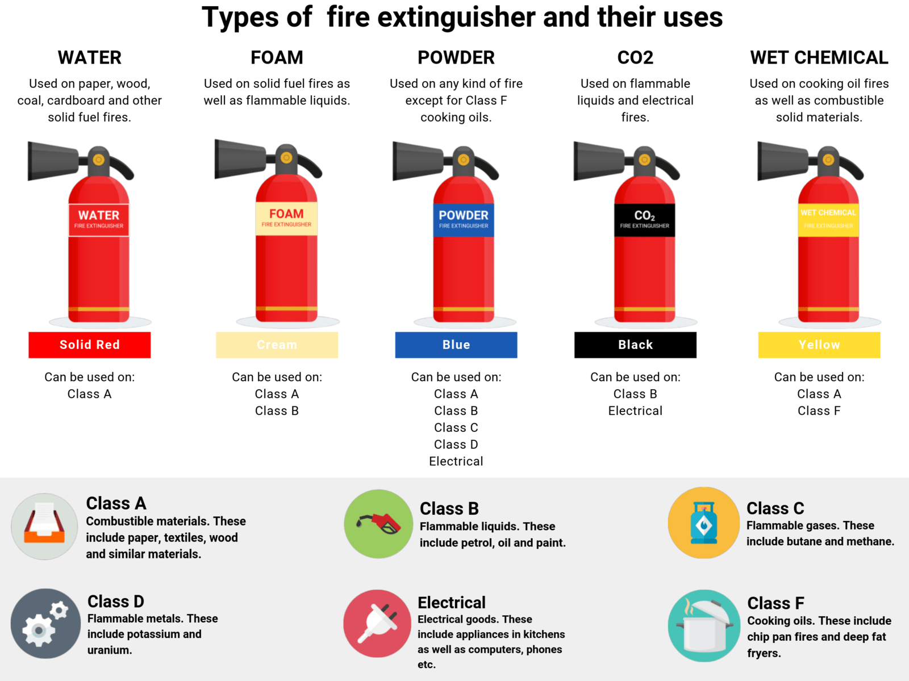

All fire equipment must be purchased through The Premises Department.
Prior to purchasing new equipment, ensure that the equipment is then included on the annual maintenance programme.

Fire Signage
Fire Action Notices The fire action notice contains generic information on the procedures that colleagues should take in the event of discovering a fire or the alarm being activated.
Managers need to ensure that the blank sections are completed by each site to identify their own specific fire management arrangements including the fire assembly point or the location of the nearest fire exit.
Until this information is filled in, this sign is not considered as valid

Fire Exit Signage – ‘Safe Condition’ Signs
Fire exit signs, final fire exit signs and directional fire exit signs must be indicated with a pictogram/graphic symbol (see below for examples). Exit signs must have a green background, with white text. The use of additional text on the signs is optional, but gives extra clarification and helps to avoid misinterpretation.

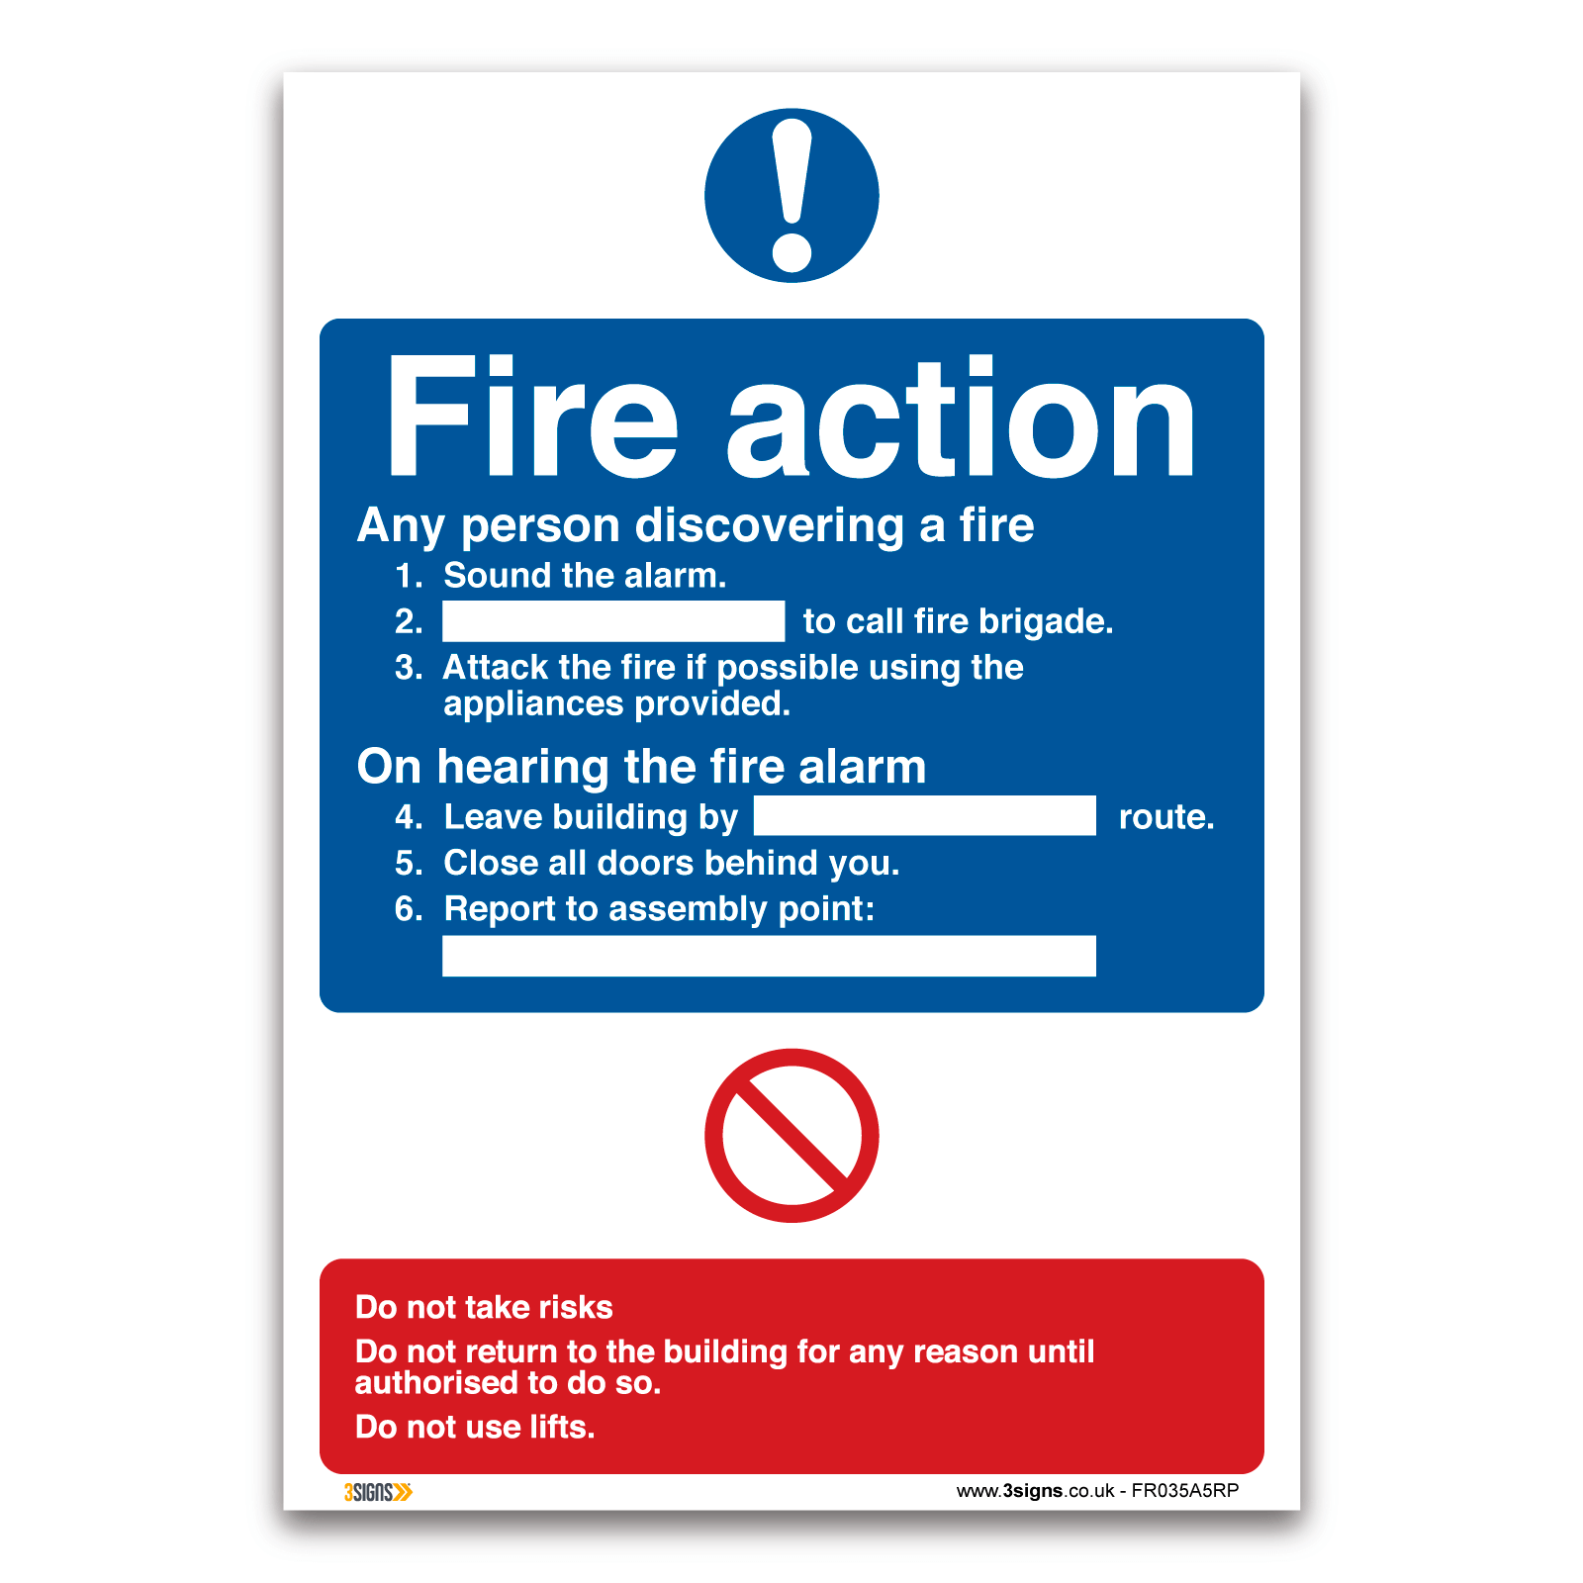
Text only exit signs are no longer acceptable and must be replaced

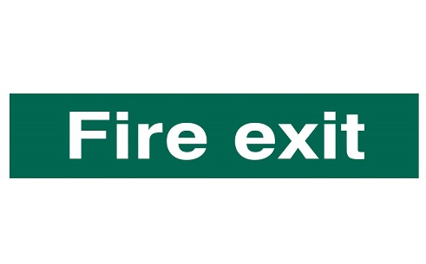

Examples of suitable exit signs (pictogram only signs are acceptable) Both styles of pictogram signage are acceptable, however a mix of design standards in the same building must be avoided.

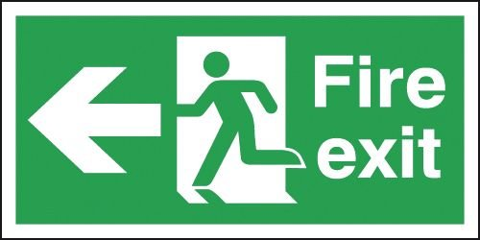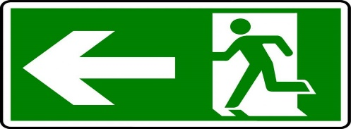

Fire Fighting Equipment Signs Example of typical signage for fire-fighting equipment. This type of sign, including directional arrows must have a red background with a white pictogram / text.

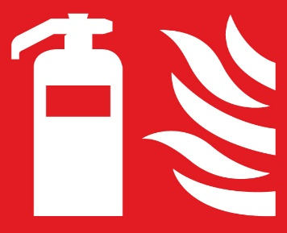

Fire Door Signage – ‘Mandatory’ Signs Example of typical signage for a fire door. This type of sign must have a blue background with a white pictogram/text.

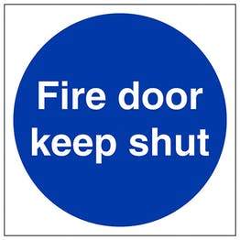

Personal Emergency Evacuation Plans (PEEP’s)

As part of the Management of Fire Risk assessment, consideration must be made for the safe evacuation of all persons on your site.
Where any colleagues work in the building, it is important that their needs are properly identified and adequate written arrangements are completed using the PEEP process.
These arrangements may include the creation of ‘Personal Emergency Evacuation Plans’ (PEEP) that identify the needs of specific individuals and details of other colleagues who would assist them in the event of an emergency.
Suitable evacuation plans may also need to be in place for visitors to certain buildings. For example, procedures adopted with regard to colleague with mobility issues employed within the building may well be different from those for a person visiting the building with similar needs due to the lack of familiarity with the layout of the building.
Any manager with responsibility to oversee the evacuation process of premises is required ensure that any person involved in the evacuation of colleagues who is covered by a PEEP is kept informed of the specific needs of those colleagues.
For multi occupancy premises, it is recommended that all PEEPs are maintained in such a location that it is available to all appropriate colleagues (fire wardens / marshals etc)

Evacuation Arrangements
Horizontal Evacuation to a Place of Safety
This system can be used in buildings with a phased alarm system and involves people passing from one ‘fire compartment’ to a place of safety within another which was not part of the initial evacuation zone.
A ‘fire compartment’ is a part of a premises separated from other parts of the same building by fire-resisting walls, doors, ceilings and floors and provides a place of fire safety for a minimum of 30 minutes .

Evacuation Points
If safe to do so, the evacuation points are as follows:
Main School Building including residence assemble at the tennis courts
Juniors Assemble in their play area
Chimes and Primary assemble in between the Chimes and Primary buildings
6th Form assemble in their rear garden

Fire Safety Information, Instruction and Training

New employees and agency colleagues must be told about emergency procedures and shown the means of escape on their first day of employment.
This is identified within Dawn House’s Employee induction programme and must be done in the location the person will work or be based from.
All employees should receive appropriate fire precautions training / information at least once a year. This training / information may include, as appropriate:
- Action to take when a fire is discovered, including how to raise the alarm;
- What to do if you hear the alarm;
- Procedures for alerting and evacuating members of the public;
- Arrangements for calling the fire brigade
- Location of fire escape routes and the identified fire assembly point;
- Importance of keeping fire doors closed (to prevent the spread of fire, heat and smoke);
- The location and, where appropriate, the use of firefighting equipment;
- How to stop machines and isolate power;
- The importance of general fire safety and good housekeeping.
This training can be delivered by the Premises Manager and may be delivered as part of a team meeting or following a fire drill.
Any information that may also affect contractor’s safety regarding fire management must be raised with them. It is also important that if you have contractors on site who are going to impact your fire safety arrangements that this is discussed prior to work commencing.

Fire Warden Training
Dawn House school considers trained Fire Wardens as an effective means of managing fire safety. As part of the fire risk assessment, a consideration of the need to have trained Fire Wardens must be given.

Checking Fire Safety
Regular checks to monitor fire safety must be made at all workplaces.
These checks should be co-ordinated by the responsible person.
- Daily – Visual checks of fire extinguishers, ,fire signage, and that fire exits are kept clear. Done by the Premises Team Member when unlocking the building.
- Weekly – Full site fire alarm functional test. A different call point for each test.
- Monthly – Emergency Lighting Test, Fire Extinguisher checks, Ansul checks, Fire exit
- 6 Monthly – Fire Alarm Service by external contractor
- Annually – Fire Risk assessment review, Emergency lighting service, Fire Extinguisher Service, Ansul Service
All checks should be more formal and recorded in the fire logbook, e.g. emergency lighting tests. Matters that should be checked if in place within your premises are included in the Fire Risk Assessment Form and the fire log book.

Reporting Fires
All fire incidents that occur within Dawn House premises, however minor, must be recorded using the correct Fire Incident Report Form which is located within the fire log book.
Instructions on what to do with the completed Fire Incident Report are detailed on the form.
In addition, where a fire results in any injury to colleagues or third parties (public, service users, pupils, etc.), it must be reported using the accident reporting system.

Hot Working and Hot Working Permit to Work
When any ‘hot work’ is carried out within a premises, such as gas welding and cutting and the use of bitumen burners in re-roofing etc, it is the responsibility of both the contractor who is in charge of the work to be undertaken and the responsible person on site to maintain fire safety arrangements. A hot work permit to work form must be completed prior to any ‘hot work’ commencing.
This document must identify the work to be carried out and the relevant safety precautions in place during the duration of the work.
The permit and warning notice must be displayed at the point of action.
The Hot Work Permit is available on the Shared drive, under Premises, Permits To Work.

Work on Fire Alarm Systems or other Fire Protection Systems within the Premises
Managers must ensure that when any work is to be done to the fire protection within a premises, the responsibilities of the contractor and responsible person are in place and that they work together to ensure that fire safety arrangements are maintained.
This must include, where applicable informing other managers, fire wardens and all affected colleagues of the amended actions required during the period that the fire alarm system is deactivated and / or changes to the evacuation routes as necessary to maintain a safe means of egress in the event of an emergency.
It is also important that safety representatives are kept informed of this information.
Managers must ensure that when a fire alarm is to be de-activated for any period of time, contact must be made with the Insurance Company so that they are aware of the situation and can provide advice if deemed appropriate.
References and Further Information
The following information and reference material is in place to assist managers to understand their responsibilities and duties.

External References
• The Regulatory Reform (Fire Safety) Order 2005 (HSE)
• INDG 370 – ‘Controlling Fire & Explosion Risks in the Workplace’ (HSE)

